**Model interpretations**

**Model 1: No variables only intercept**

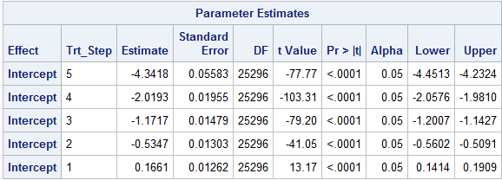

**Intercept 5 = logit of probability of y > 4 = exp(-4.3418) / (1+ exp(-4.3418)) =**

**P(y=0) = 1- intercept 1 = 1**